EXERCISE

Q1

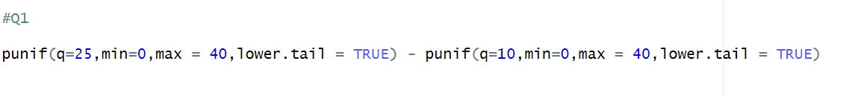



Q2

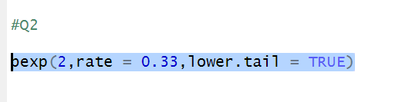



Q3 – part 1 , part 2

